**HANOI UNIVERSITY OF SCIENCE AND TECHNOLOGY**

SCHOOL OF INFORMATION AND COMMUNICATIONS TECHNOLOGY



**Capstone project report:**

**Smart Farm – Crop Growth & Resource Management Simulator**

**Supervised by:**

Assoc. Prof. Dr. Nguyen Thi Thu Trang

**Group Members:**

|  |  |
| --- | --- |
| Vu Duc Duy | 202416686 |
| Vu Do Minh Thao | 202416752 |
| Nguyen Minh Dung | 202416682 |
| Vo Chien Huy | 20215208 |

Hanoi - Vietnam

2026

# **TABLE OF CONTENTS**

**TABLE OF CONTENTS 2**

**ASSIGNMENTS 4**

**CHAPTER 1: INTRODUCTION 5**

1.1 Problem Statement 5

1.2 Project Motivation 5

1.3 System Overview 5

1.4 Key Features 5

1.5 Project Scope 6

**CHAPTER 2: SYSTEM DEMONSTRATION 7**

2.1 Main Menu Interface 7

2.2 Game Interface Overview 8

2.3 Farm Grid and Crop Visualization 10

2.4 Store and Inventory System 11

2.5 Crop Inspection and Management 13

2.6 Notification System 15

**CHAPTER 3: DEVELOPMENT ENVIRONMENT 17**

3.1 Development Tools 17

3.2 External Libraries Used 17

**CHAPTER 4: SYSTEM ARCHITECTURE 18**

4.1 Overall Architecture 18

4.2 Package Structure 18

4.3 Component Interaction 21

**CHAPTER 5: CLASS DESIGN 22**

5.1 Core Model Classes 22

5.2 Controller Classes 26

5.3 Service Classes 27

5.4 Utility Classes 28

**CHAPTER 6: KEY GAME MECHANICS 30**

6.1 Crop Growth System 30

6.2 Resource Management 31

6.3 Store and Economy System 31

6.4 Random Event System 32

6.5 Save/Load Functionality 33

6.6 Day Progression 34

**CHAPTER 7: OOP PRINCIPLES APPLIED 35**

7.1 Inheritance 35

7.2 Encapsulation 35

7.3 Polymorphism 35

7.4 Abstraction 36

**CHAPTER 8: LIMITATIONS AND FUTURE WORK 37**

8.1 Current Limitations 37

8.2 Proposed Improvements 37

**CHAPTER 9: CONCLUSION 38**

9.1 Project Summary 38

9.2 Learning Outcomes 38

9.3 Final Remarks 38

**REFERENCES 39**

# 

# 

# 

# 

# 

# 

# 

# 

# 

# 

# 

# 

# 

# **ASSIGNMENTS**

|  |  |  |  |  |
| --- | --- | --- | --- | --- |
| No | Name | Student ID | Work Assignment | Completion |
| 1 | Vũ Đức Duy | 202416686 | Video Demo Edit, Core Logic Farm, Notification Management, GameEvent system, MainGame UI, Main GamePlay Interactions, Main idea contribution, write report. | 35% |
| 2 | Vũ Đỗ Minh Thảo | 202416752 | Class Diagram, UseCase Diagram, develop player management module,  Exception handling, create MainMenu UI and Scene Navigator, save/load game mechanism, write report | 34% |
| 3 | Nguyễn Minh Dũng | 202416682 | Inventory, Store, Resource Management, Help Section, Main Menu and Game UI edit, Write report, | 30% |
| 4 | Võ Chiến Huy | 20215208 | Initial Idea Contribution, Task Assignment | 1% |

# **CHAPTER 1: INTRODUCTION**

## 

## 1.1 Problem Statement

In computer science education, students often learn Object-Oriented Programming (OOP) concepts theoretically without sufficient practical application. While fundamental principles such as inheritance, encapsulation, polymorphism, and abstraction are taught extensively, there remains a gap in engaging projects that demonstrate how these concepts work together in a cohesive system. This project addresses this gap by developing a farming simulation game that demonstrates OOP principles in an interactive and practical context, providing both educational value and hands-on implementation experience.

## 1.2 Project Motivation

The motivation for this project stems from several interconnected factors. First, farming simulation games provide an intuitive context where real-world concepts naturally map to programming constructs. Crops share common behaviors yet possess unique characteristics, making them ideal candidates for demonstrating inheritance hierarchies and polymorphic behavior. Additionally, the project provides an opportunity to implement a complete Model-View-Controller (MVC) architecture with clear separation between game logic, user interface, and interaction handling. This architectural approach demonstrates professional software design patterns applicable to larger-scale applications. Furthermore, the interactive and visual nature of farming games creates an engaging learning environment. Immediate visual feedback and the satisfaction of managing a successful farm make programming concepts more tangible and memorable compared to abstract theoretical examples.

## 1.3 System Overview

Smart Farm is a farming simulation game developed using Java and JavaFX framework. The system allows players to manage a virtual farm through planting crops, maintaining resources, and harvesting produce for economic gain. The game simulates realistic farming mechanics where crops progress through distinct growth stages (Seed, Seedling, Mature, Harvestable) and require regular maintenance including water and fertilizer. Environmental factors are modeled through a random event system that can introduce challenges such as rain, drought, or pest attacks, requiring players to adapt their resource management strategies dynamically. The application is built on Model-View-Controller (MVC) architecture, demonstrating proper separation of concerns. The Model layer handles game state and business logic, the View layer manages JavaFX-based user interface with isometric grid visualization, and the Controller layer coordinates interactions between model and view components.

## 1.4 Key Features

The system implements the following core features:

* **Crop Management System**: Five distinct crop types (Wheat, Corn, Carrot, Tomato, Pumpkin) with unique growth rates, resource requirements, and economic values. Crops progress through multiple growth stages with visual representations.
* **Resource Management System:** Comprehensive inventory tracking monetary funds, water, fertilizer, medicine, and seeds. Players must balance resource consumption against acquisition to maintain sustainable operations.
* **Store System:** Interactive purchasing interface enabling players to buy resources and seeds using currency earned from harvests, creating an economic feedback loop.
* **Random Event System**: Environmental events including Rain (increases water levels), Drought (inflicts health damage), and Pest Attacks (applies random damage), demonstrating polymorphic behavior.
* **Crop Health System**: Individual crop health monitoring with medicine-based recovery or recycling mechanics for deceased crops, encouraging efficient resource cycling.
* **Save and Load System:** Complete game state persistence using Java serialization, allowing players to continue progress across multiple sessions.
* **Notification System**: Comprehensive activity logging with in-game board access, providing transparency and feedback for all player actions and events.

## 

## 1.5 Project Scope

This project focuses on demonstrating Object-Oriented Programming principles through a single-player farming simulation with core resource management mechanics.

The implementation encompasses:

1. Game Mechanics

* Five distinct crop types (Wheat, Corn, Carrot, Tomato, Pumpkin) with complete growth lifecycle from seed to harvest
* Resource management including water, fertilizer, and medicine
* Economic system with purchasing and selling functionality
* Environmental events (Rain, Drought, Pest Attacks)

1. Software Architecture

* Model-View-Controller design pattern with clear separation of concerns
* JavaFX framework for graphical interface with isometric grid visualization
* Persistent storage using Java serialization
* Robust error handling with custom exceptions

1. Project Deliverables

* Well-documented source code
* UML diagrams illustrating system design
* Comprehensive technical documentation

The scope is intentionally limited to desktop single-player functionality to allow in-depth focus on demonstrating OOP principles, design patterns, and software engineering best practices within the project timeline.

# **CHAPTER 2: SYSTEM DEMONSTRATION**

## 2.1 Main Menu Interface

The Main Menu serves as the primary entry point for the **Smart Farm** application. It features a clean, minimalist design with a green aesthetic to reflect the agricultural theme of the game.

**Functional Components:**

* **Start Game**: Initializes a new session by resetting all farm resources and variables.
* **Continue**: Resumes the game by loading the most recent progress from the system's save files.
* **Help**: Displays a guide containing instructions on game mechanics and controls.
* **Exit**: Safely terminates the JavaFX application and closes all active processes.

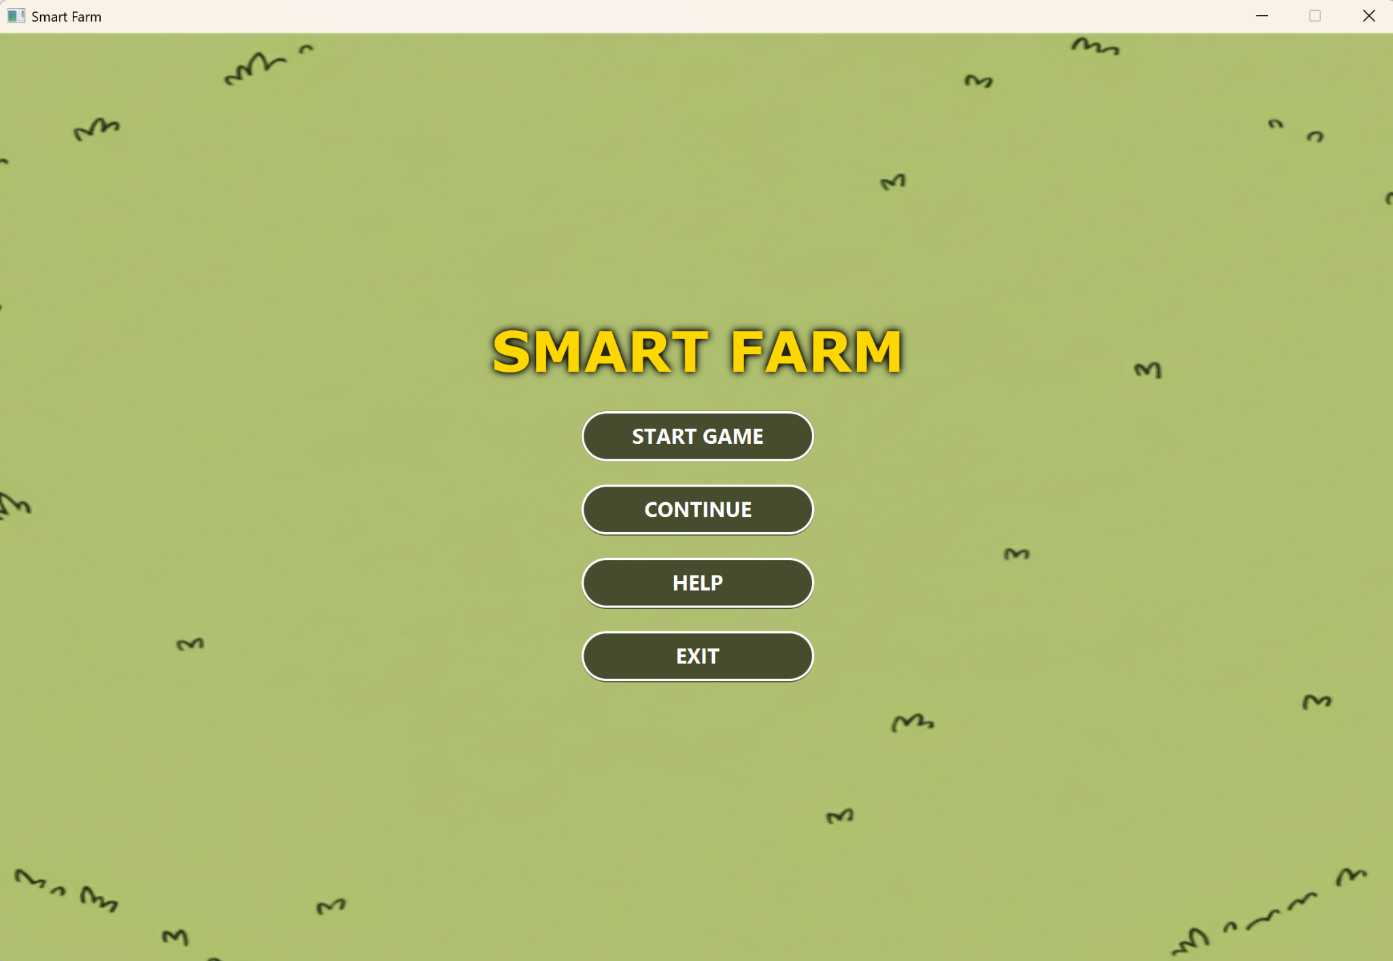

Figure 2.1.1: Smart Farm interface at startup

Player can also view Help to see the tutorial

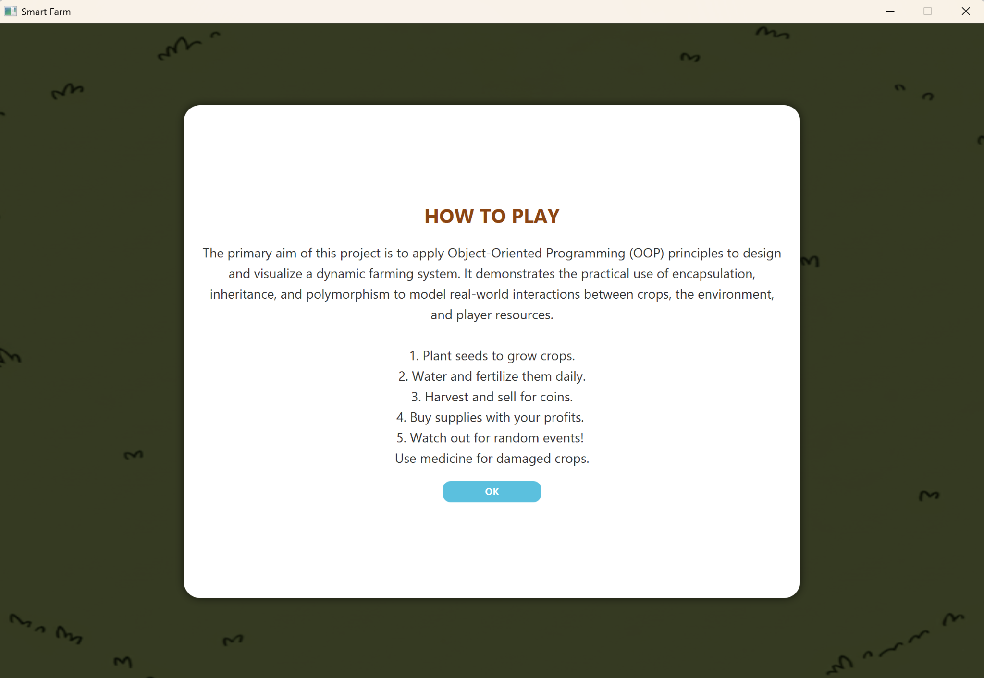

Figure 2.1.2: Help menu

## 2.2 Game Interface Overview

The main game interface utilizes a comprehensive layout designed to provide both visual appeal and functional accessibility. The interface is divided into several key regions to facilitate efficient gameplay:

* **Farm Grid (Main Viewport)**: The center area displays the farm grid using isometric projection, consisting of $5×5$ cells where crops can be planted and managed.
* **Status Dashboard**: Positioned in the upper-left region, this board displays the current game day, player money ($500), water (200), and fertilizer (100) units.
* **Navigation and Persistence**: The "NEXT DAY" button at the top-right advances the game time, while the "SAVE & EXIT" button at the bottom-right allows players to secure their progress.
* **Quick Access Sidebar**: The right sidebar contains dedicated icons for the Store and Inventory systems, allowing for rapid resource procurement and management.
* **Information Hub**: A notification button is located in the upper-right area to trigger the display of recent actions, such as resource usage and environmental events like rain

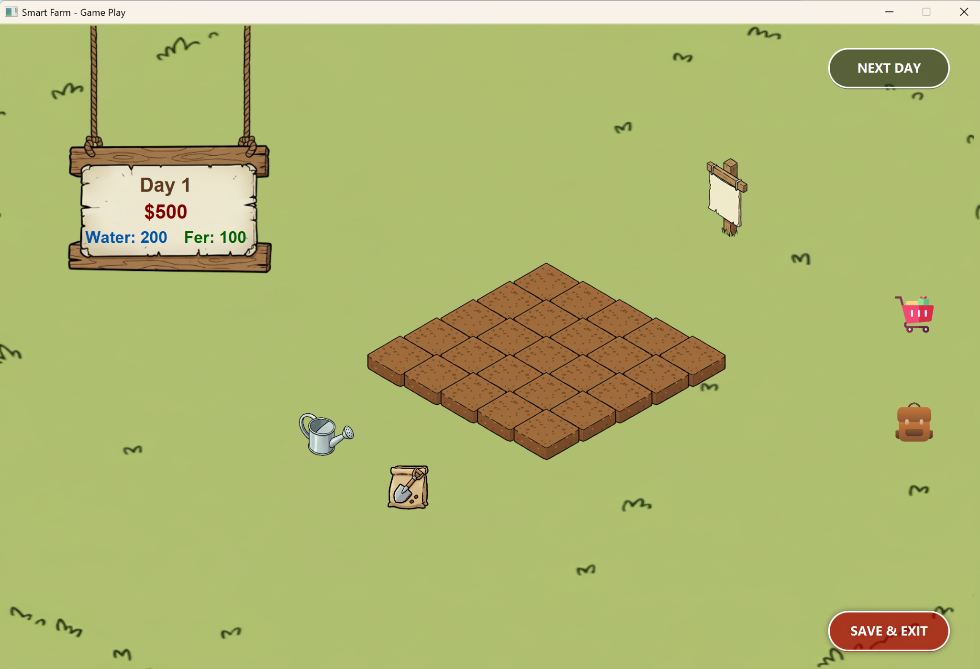

Figure 2.2.1: Main GamePlay of Smart Farm

### 2.2.1 Quick-Use Tool Interaction

To streamline farm management, the interface includes dedicated interactive tools located in the bottom-left region. These tools allow for precise resource application through specialized modal dialogs.

* **Resource Application Popups**: Clicking on the **Watering Can** or **Fertilizer Bag** icons triggers a "WATERING" or "FERTILIZER" input window.
* **Manual Amount Entry**: Unlike automated systems, this interface allows players to manually enter the specific amount of resources they wish to use (e.g., a default of 10 units for Water or 5 units for Fertilizer).
* **Action Validation**:
  + **Confirm**: Validates the numerical input and applies the resources to the selected Land object, updating the crop's status and the player's total inventory.
  + **Cancel**: Closes the dialog without consuming any resources, preventing accidental usage.
* **User Interface Consistency**: These popups follow the project's visual theme, utilizing rounded corners, clear typography, and color-coded buttons (**Green** for Confirm and **Red** for Cancel) to enhance user intuition.

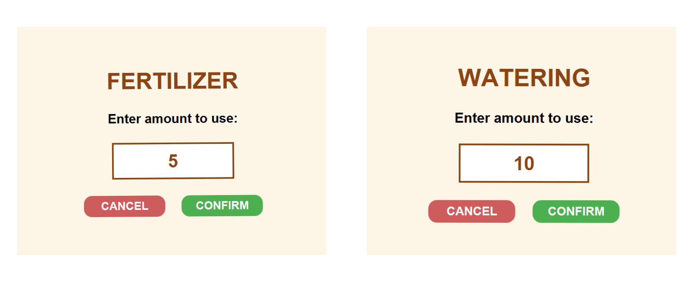

Figure 2.2.2: Resource input dialogs for precise management.

## 2.3 Farm Grid and Crop Visualization

### 2.3.1 Farm Grid System:

The farm employs a $5×5$ isometric grid layout where each cell represents an independent plot of land. This modular design facilitates flexible crop placement and granular cell management.

**Grid Cell States:**

* **Empty**: Displays a brown soil texture, indicating the plot is ready for planting.
* **Occupied**: Displays a crop at one of its distinct growth stages, visually indicating progress from sprout to harvest.

**Interactive Feedback:**

* **Hover Effects**: Cells brighten when the cursor hovers over them to provide immediate **visual feedback** to the player.
* Selection Highlighting: Active plots are highlighted with a yellow glow effect, ensuring the player can easily track which plot is currently being managed.

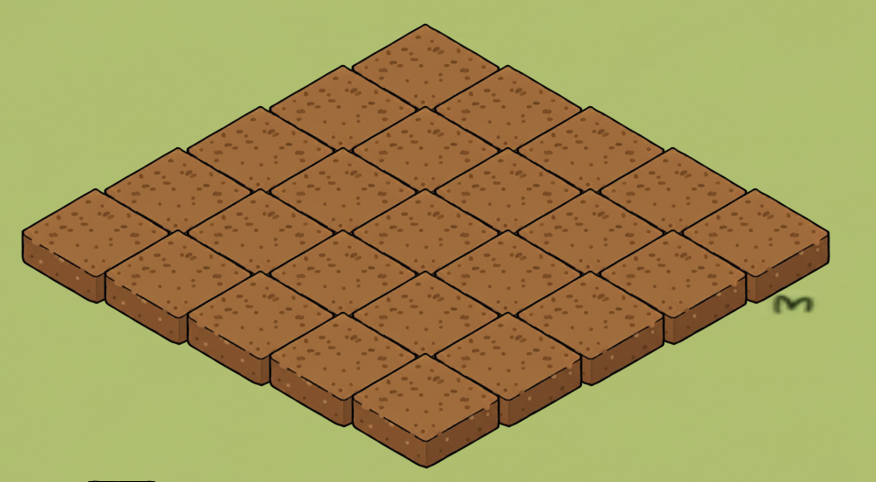

Figure 2.3.1: Demonstration of farm grid

### 2.3.2 Crop Visualization

The system utilizes distinct assets for each growth stage of the crops. As a representative example, **Figure 2.3.2** illustrates the visual progression of the **Corn crop** through its four primary stages: Seed, Seedling, Mature, and Harvestable.

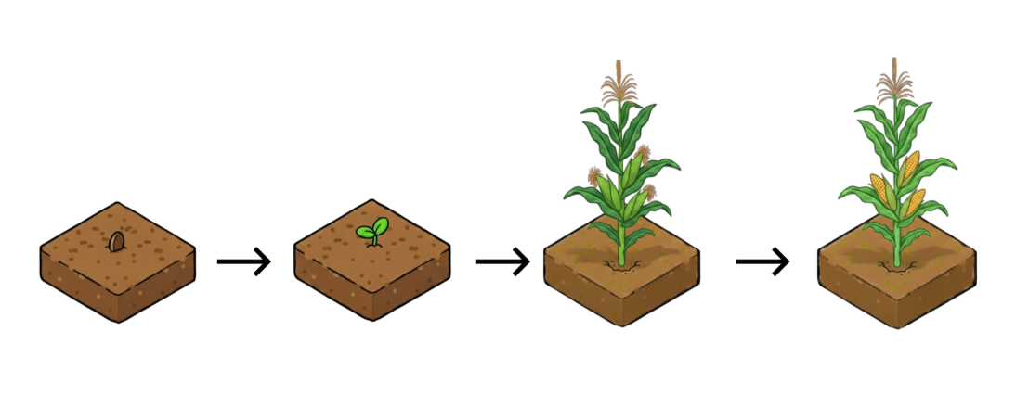

Figure 2.3.2: Representative growth stages of the Corn crop

## 2.4 Store and Inventory System

### 2.4.1 Store Interface

The Store acts as the primary marketplace where players exchange game currency for farming essentials.

* **Product Variety**: The store features a diverse catalog including various seed types (Wheat, Corn, Carrot, Tomato, Pumpkin) and maintenance supplies (Fertilizer, Water, Medicine).
* **Price Transparency**: Each item is displayed with its specific cost—ranging from $2 for Water to $50 for Medicine—allowing players to make informed financial decisions.
* **Transaction Management**: The interface displays the player's current balance to ensure they can track their remaining funds during a shopping session.

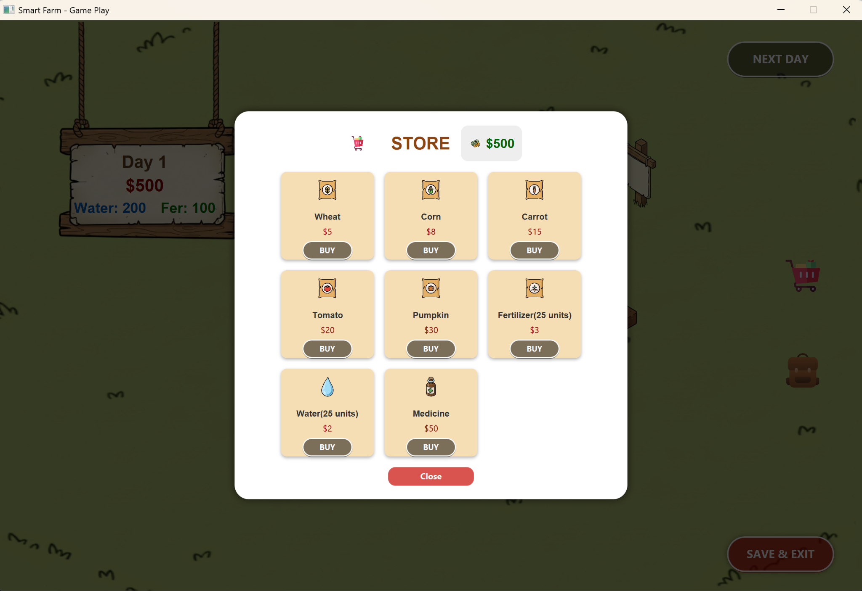

Figure 2.4.1: Store interface showing available items and pricing

### 2.4.2 Inventory System

The Inventory provides a centralized view of all resources currently owned by the player.

* **Quantity Tracking**: The system accurately monitors and displays the exact amount of each seed type and supply held in storage.
* **Asset Categorization**: Items are neatly organized into dedicated slots, such as Wheat Seeds and Pumpkin Seeds, for quick identification during gameplay.
* **Resource Readiness**: By showing "Amount: 0" for unowned items, the interface alerts players when they need to return to the store to replenish their stock.

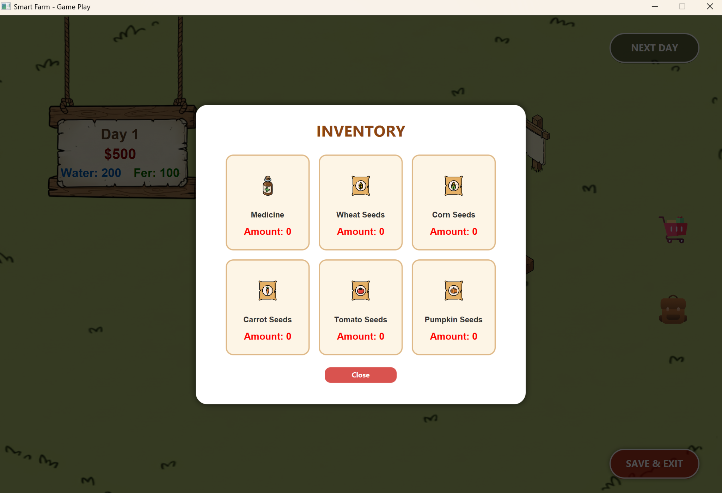

Figure 2.4.2: Inventory interface displaying stored seeds and medicine

## 2.5 Crop Inspection and Management

#### **2.5.1 Planting Procedure**

The seed selection interface is designed as a clean modal popup, ensuring user focus remains on the planting decision while maintaining the game's aesthetic.

* **Visual Design**: The interface features a white background with rounded corners and a modern, minimalist layout.
* **Seed Grid Layout**: Crops are organized in a grid, with each entry displaying its respective icon, name, and current inventory count (e.g., "Left: 2").
* **Smart Validation**: To prevent invalid gameplay actions, the "PLANT" button is automatically disabled and grayed out when a seed type is out of stock ("Left: 0"), effectively guiding the player to restock at the store.
* **Navigation Control**: A prominent "Cancel" button at the bottom allows players to exit the menu without making a selection, maintaining a fluid and non-intrusive user experience.

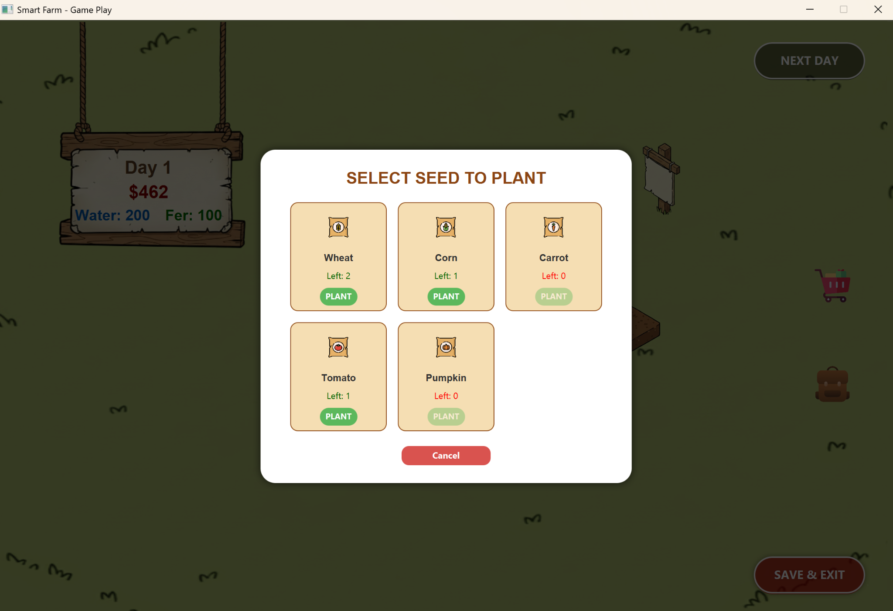

Figure 2.5.1: Seed selection menu triggered by clicking empty land

#### **2.5.2 Crop Status and Care**

Once a crop is planted, players can perform real-time monitoring and management to ensure optimal growth.

**Detailed Inspection:** Clicking on a growing crop opens a status window providing essential data:

* **Health:** Indicates the overall physical condition of the plant.
* **Water & Fertilizer Levels:** Displays current levels versus maximum capacity.
* **Growth Progress:** Shows the remaining "Days to Harvest."

**Management Actions:** The interface includes interactive buttons for direct care:

* **Water (-10):** Consumes water resources to hydrate the plant.
* **Fertilize (-5):** Adds fertilizer to boost growth.
* **Medicine:** Used to treat diseases if the plant's health declines.

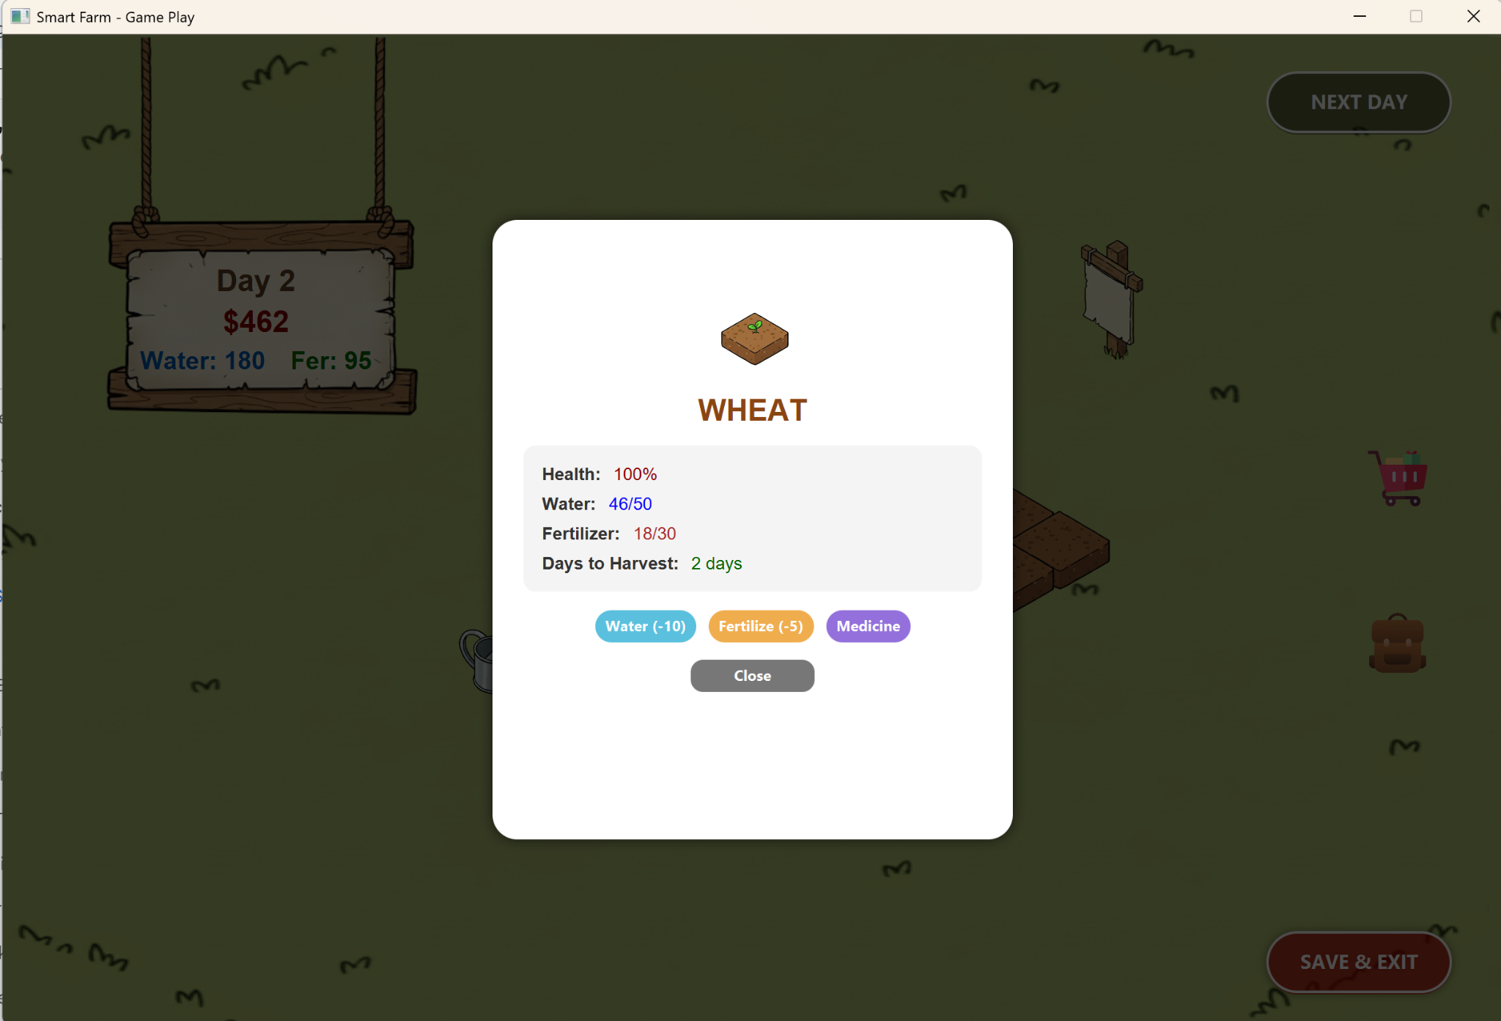

Figure 2.5.2: Detailed crop status and management options

## 2.6 Notification System

The Notification System serves as a centralized communication hub, providing players with a chronological log of both their personal actions and external environmental events.

**Key Features:**

* **Dynamic Event Tracking:** The system monitors and reports random environmental changes that impact the farm. For example, it notifies players when weather events occur, such as "Rain appears," which automatically replenishes water for all crops.
* **Activity Logging:** Every significant player interaction is recorded with a timestamp indicating the specific game day. This includes the consumption of resources like water and fertilizer (e.g., "[Day 1] Used 10 Water").
* **Status Updates:** Beyond manual actions, the log provides feedback on the initial startup of the game session, ensuring a clear transition into the gameplay loop.
* **Information Management:** By presenting history in a clear, list-based format, the notification window helps players review their recent strategies and understand the current state of their farm's ecosystem.

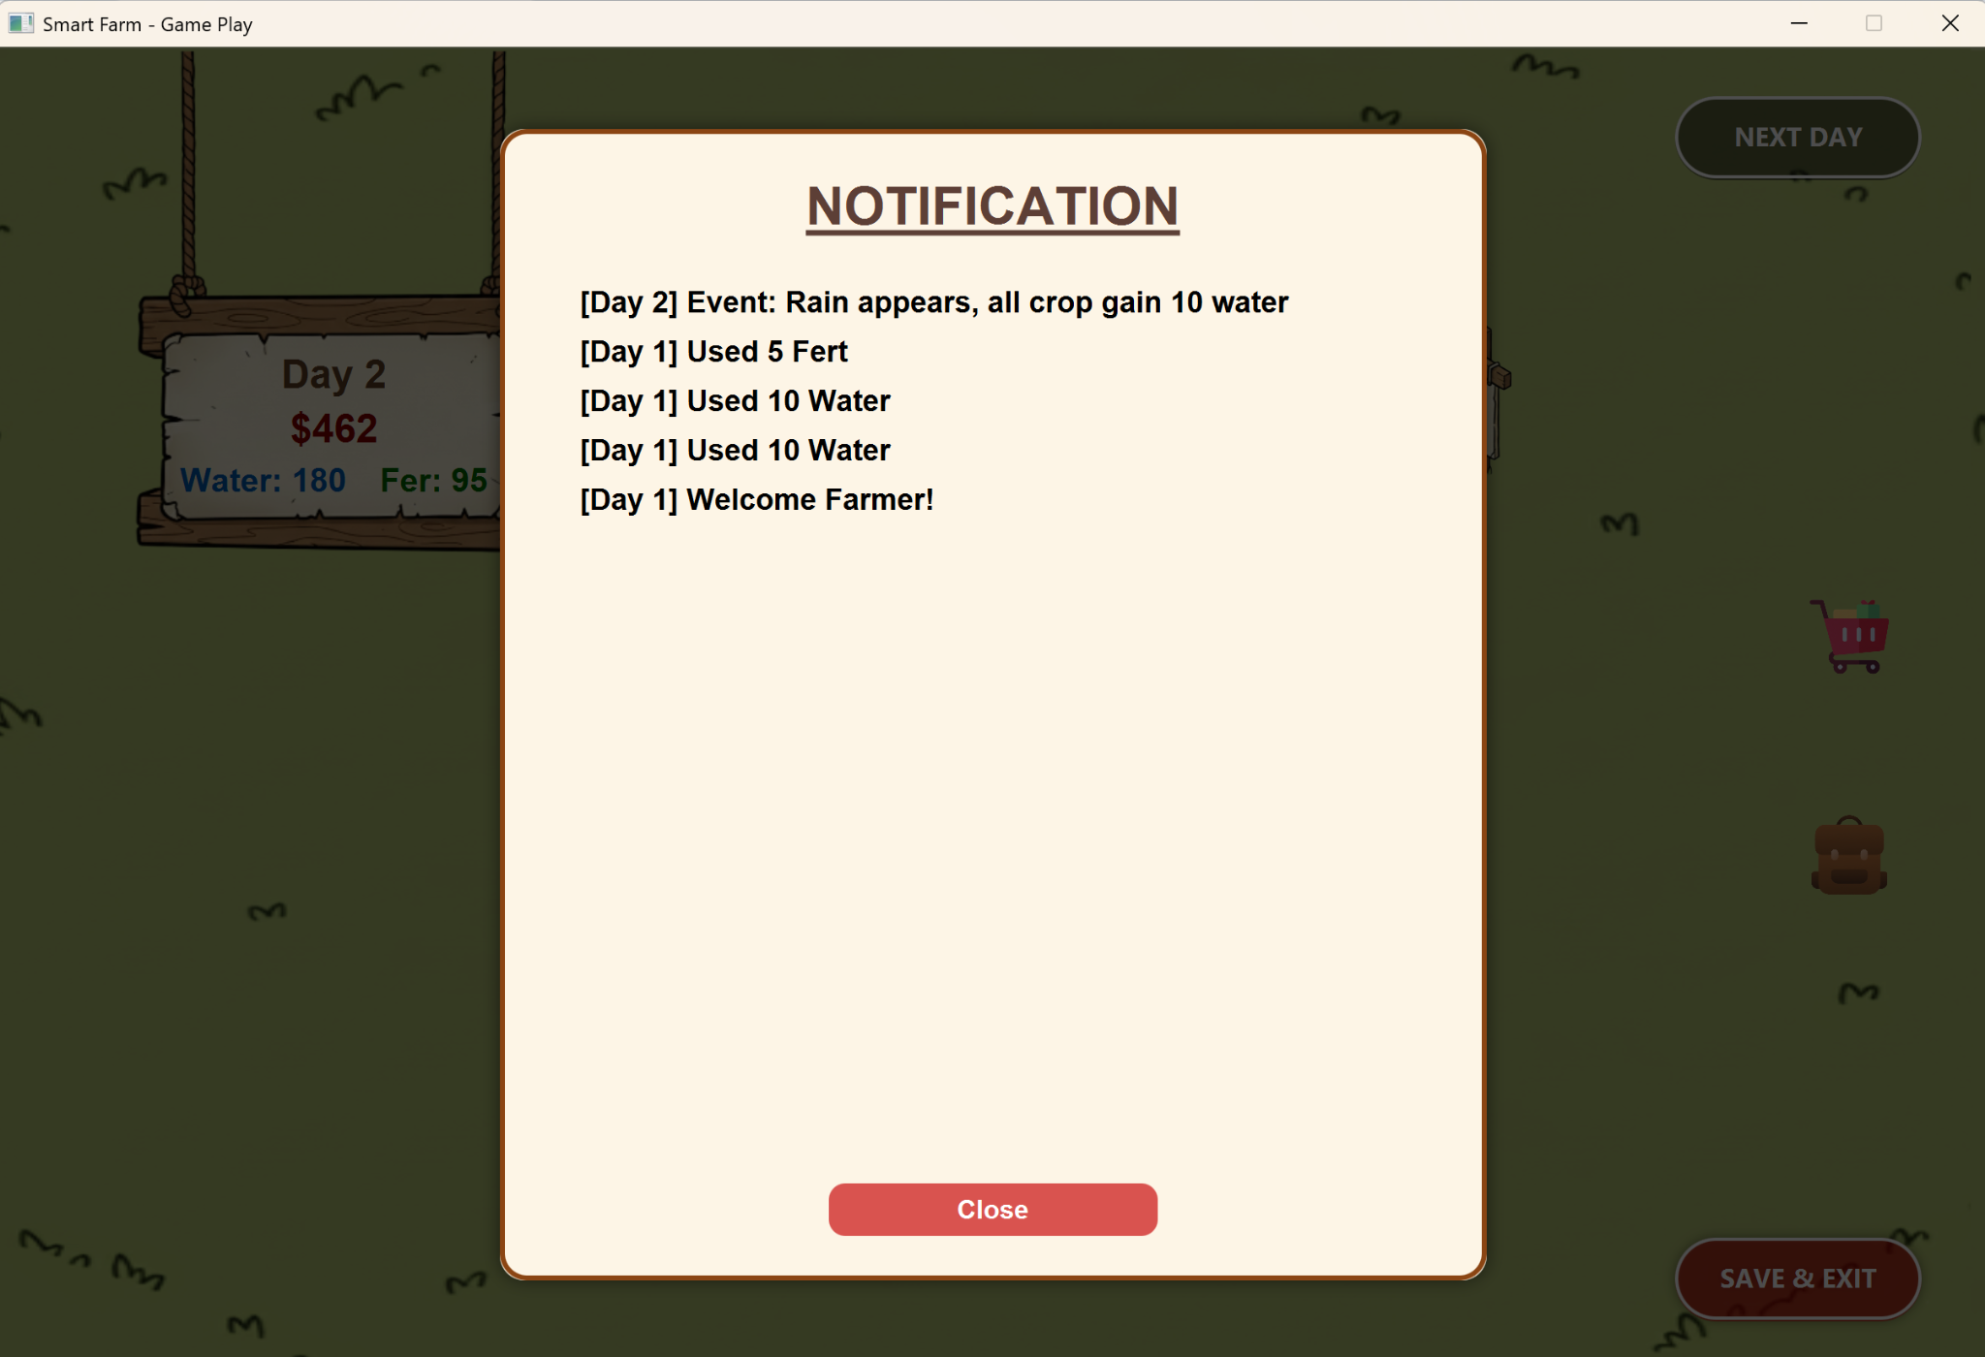

Figure 2.6.1: Notification window displaying event logs and action history

# **CHAPTER 3: DEVELOPMENT ENVIRONMENT**

## 3.1 Development Tools

This section describes the software and resources utilized to develop, design, and manage the assets of the Smart Farm project.

* **Programming Language:** The project is developed using **Java**, a robust object-oriented language that allows for the effective implementation of OOP principles such as inheritance, encapsulation, and polymorphism.
* **User Interface Framework:** **JavaFX** is employed for building the Graphical User Interface (GUI), managing FXML layouts, and rendering the isometric farm grid.
* **UI Design Tool:** **Scene Builder** was used to visually design the FXML layouts, ensuring a clean and consistent interface for the menus and game HUD.
* **Integrated Development Environment (IDE):** Both IntelliJ IDEA and Eclipse were used for coding, debugging, and managing the project’s package structure.
* **Graphic & Asset Resources:**
  + **Flaticon:** Used as the primary source for high-quality icons, including tools like the watering can, fertilizer bags, and various seed packets.
  + **Google Gemini:** Utilized as an AI generative tool to create visual assets, including background textures and various growth stages for the crops.
* **Learning & Research:**
  + **YouTube:** Served as a vital learning resource for implementing 2D game logic in Java, specifically regarding isometric grid rendering and the game loop mechanics.

## 3.2 External Libraries Used

The following external libraries were integrated to support the system's core functionalities:

* **JavaFX SDK:** The core library for rendering the graphical interface, handling user input events, and managing the Scene Navigator for transitions.
* **Java Standard Library (java.io):** Used to implement the **Serialization** mechanism, allowing the game state to be saved and loaded from local .dat files.
* **Java Standard Library (java.util):** Employed for managing collections (like the Inventory list) and generating random values for the environmental event system.

# **CHAPTER 4: SYSTEM ARCHITECTURE**

## 4.1 Overall Architecture

The Smart Farm system implements a layered architecture based on the MVC pattern, enhanced with service and utility layers to support complex game mechanics. This architectural approach ensures clear separation between user interface, business logic, and data management.

Architectural layers:

* View Layer: Implemented through the view package using JavaFX FMXL files, responsible for rendering the user interface and capturing user interactions.
* Control Layer: Contains the controller package that mediates between View and Model, handing user input and coordinating application flow.
* Model Layer: Encompasses the model package containing core game entities, player data, crops and business rules.
* Service Layer: Provides supporting services including the event system for random game events and save/load functionality.
* Utility Layer: Contains helper classes, enumerations, and factory patterns used throughout the application.

## 4.2 Package Structure

The system is organized into six primary packages, reflecting layered MVC-based architecture. Each package encapsulates a specific responsibility, ensuring high cohesion within packages and low coupling between the core logic and the view of the system.

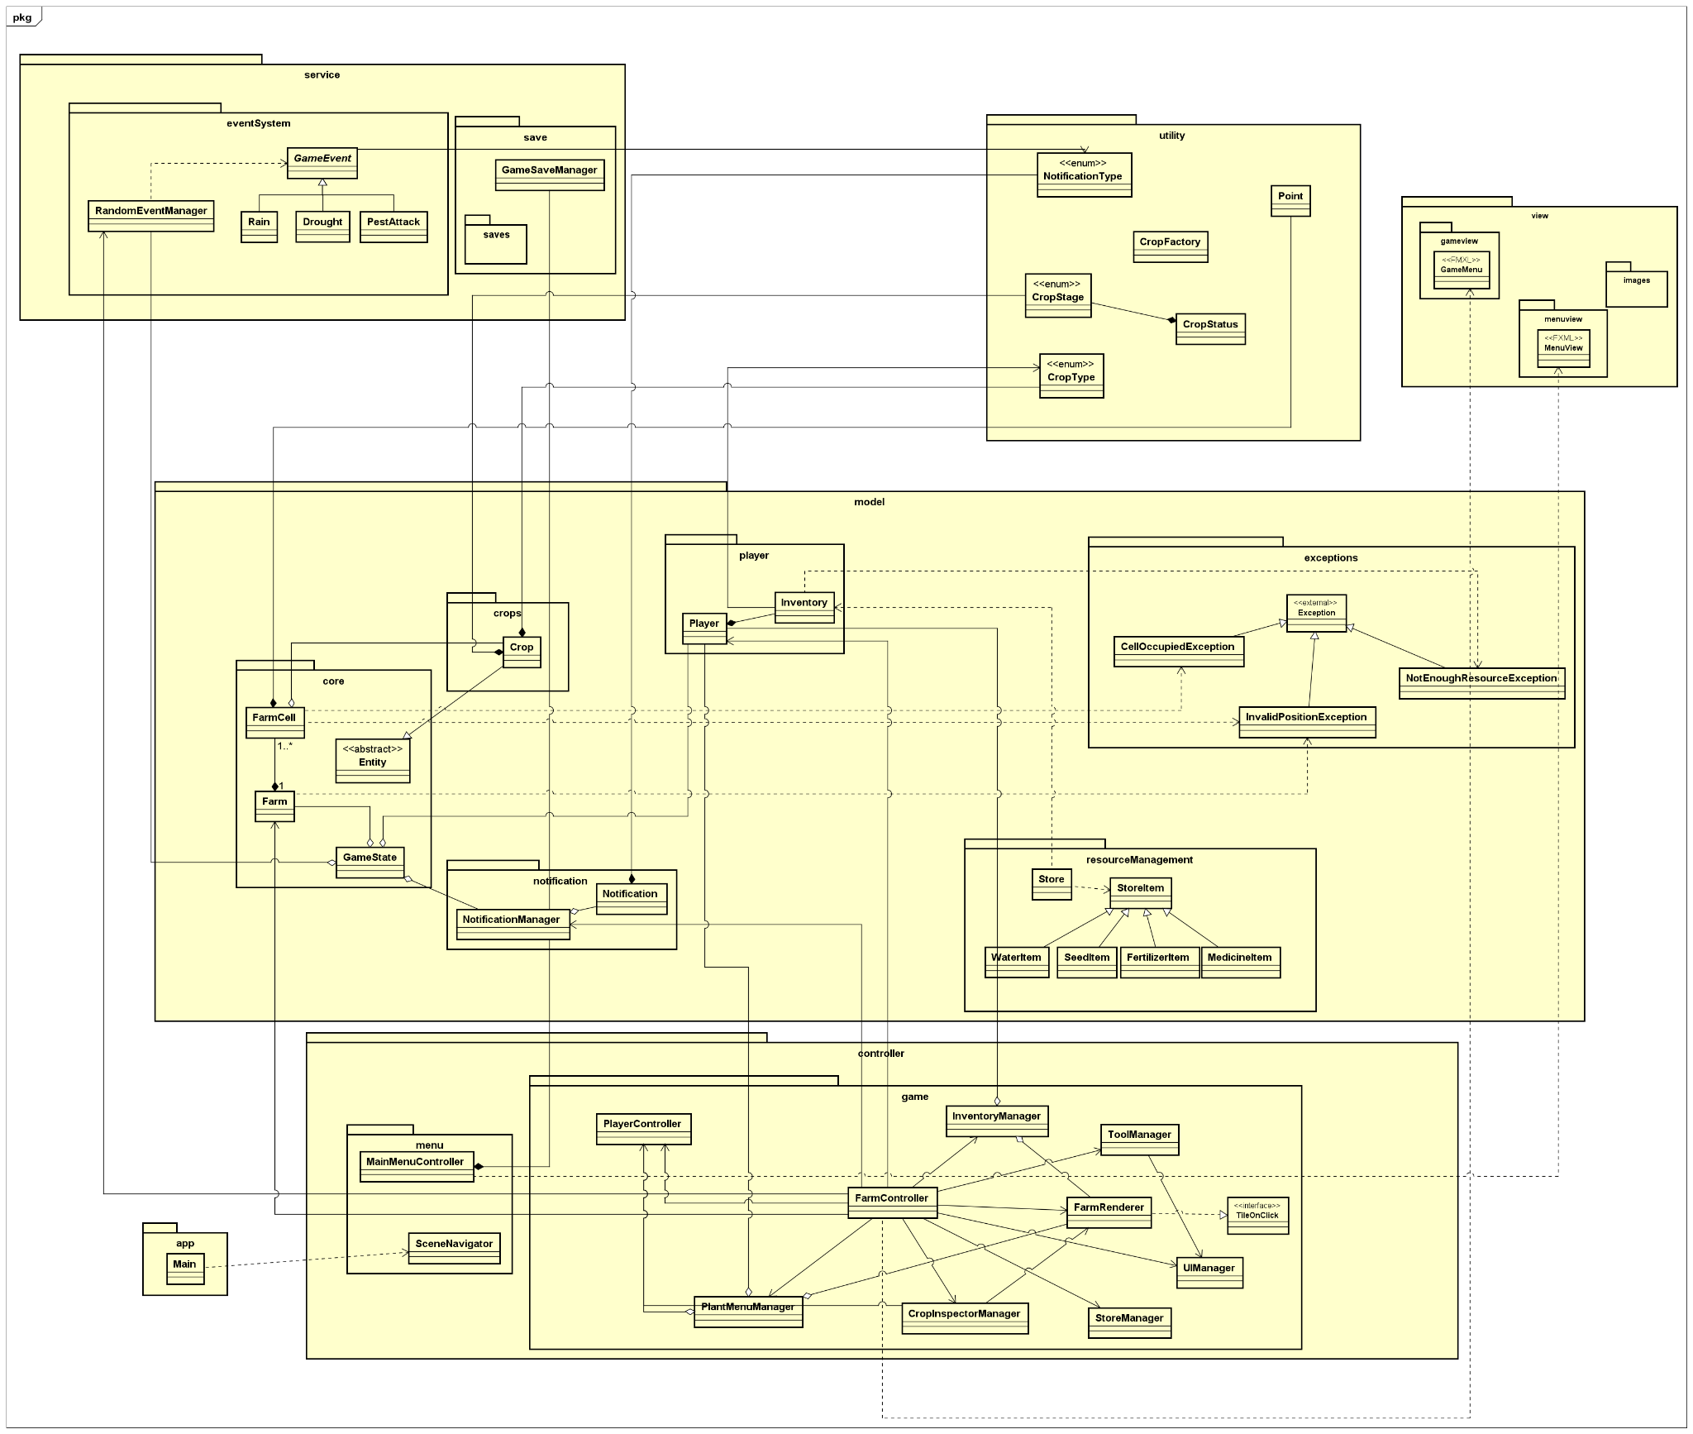

Figure 4.2. General Class Diagram

### 4.2.1 App Package

The app package serves strictly as the system’s bootstrap layer. It contains the entry point (Main.java), responsible for initializing the JavaFX lifecycle and configuring global settings.

### 4.2.2 Controller Package

The controller package is divided into two sub-packages:

* controller.menu: Manages high-level navigation, including the MainMenuController and the SceneNavigator for switching between the menu and the game environment.
* controller.game: Contains specialized managers. These classes are used for interpreting input events, validating user actions, and coordinating the flow between the view and service layers.

### 4.2.3 Model Package

The model package serves as the core of the system, storing data and enforcing the game’s business rules. This package is organized into specialized sub-packages:

* model.core: Contains foundational entities such as Farm (managing the land grid), FarmCell (representing a specific cell of land), and GameState (storing the overall state for save/load functionality).
* model.crops: Defines the Crop class, which manages the life cycle, growth stages, and health status of plants.
* model.player: Manages Player information and the Inventory system, including currency and resource tracking.
* model.resourceManagement: Handles the logic for commerce and shop items through the Store class and StoreItem abstraction.
* model.notification: An interval system for managing in-game alerts and history via Notification and NotificationManager.
* model.exceptions: Contains custom exceptions for business logic control, such as NotEnoughResourceException or InvalidPositionException.

### 4.2.4 View Package

The view package is responsible for the user interface, utilizing JavaFX FXML to decouple design from source code logic:

* view.menuview: Contains MainMenu.fxml, which defines the layout of the game’s starting menu.
* view.gameview: Contains GameMenu.fxml, which defines the primary gameplay interface including the HUD, control panels and the farm grid.
* view.images: A directory for all system image assets, including crop growth stage, tool icons, and background textures.

### 4.2.5 Service Package

The service package provides supporting features that are not inherent to entity logic but are essential for system operation:

* service.eventSystem: Manages daily random occurrences (Rain, Drought, PestAttack) through the RandomEventManager to enhance gameplay entities.
* service.save: Uses the GameSaveManager to perform read and write operations for game data to the local file system.

### 4.2.6 Utility Package

The utility package contains shared components and design patterns used across the entire application:

* Enumerations: Defines critical constant sets such as CropStage (growth phases), CropType, and NotificationType.
* Helper Classes: Provides data structure support such as Point (for coordinate management) or CropStatus.
* Patterns: Implements the Factory pattern via CropFactory to instantiate crop objects.

## 4.3 Component Interaction

Interaction between components in the Smart Farm system follows an MVC flow:

1. *Request Reception* (View to Controller): When a user interacts with the UI, an event is dispatched to the FarmController.
2. *Action Coordination* (Inside Controller): The FarmController identifies the action type. For instance, if a watering tool is selected, it coordinates with the ToolManager to verify the state or calls the PlayerController to execute the business action.
3. *Business Logic Processing* (Controller to Model): The PlayerController triggers state changes in the Model. If conditions are not met, an exception is thrown.
4. *UI Feedback* (Controller to View): Once the Model is successfully updated, the FarmController directs the FarmRenderer to redraw the farm grid and signals the UIManager to refresh labels (Money, Water) and display relevant notifications).
5. *Context Switching*: The SceneNavigator is utilized by controllers to transition between view.menuview and view.gameview while maintaining the global application state.

# 

# 

# 

# 

# **CHAPTER 5: CLASS DESIGN**

## 5.1 Core Model Classes

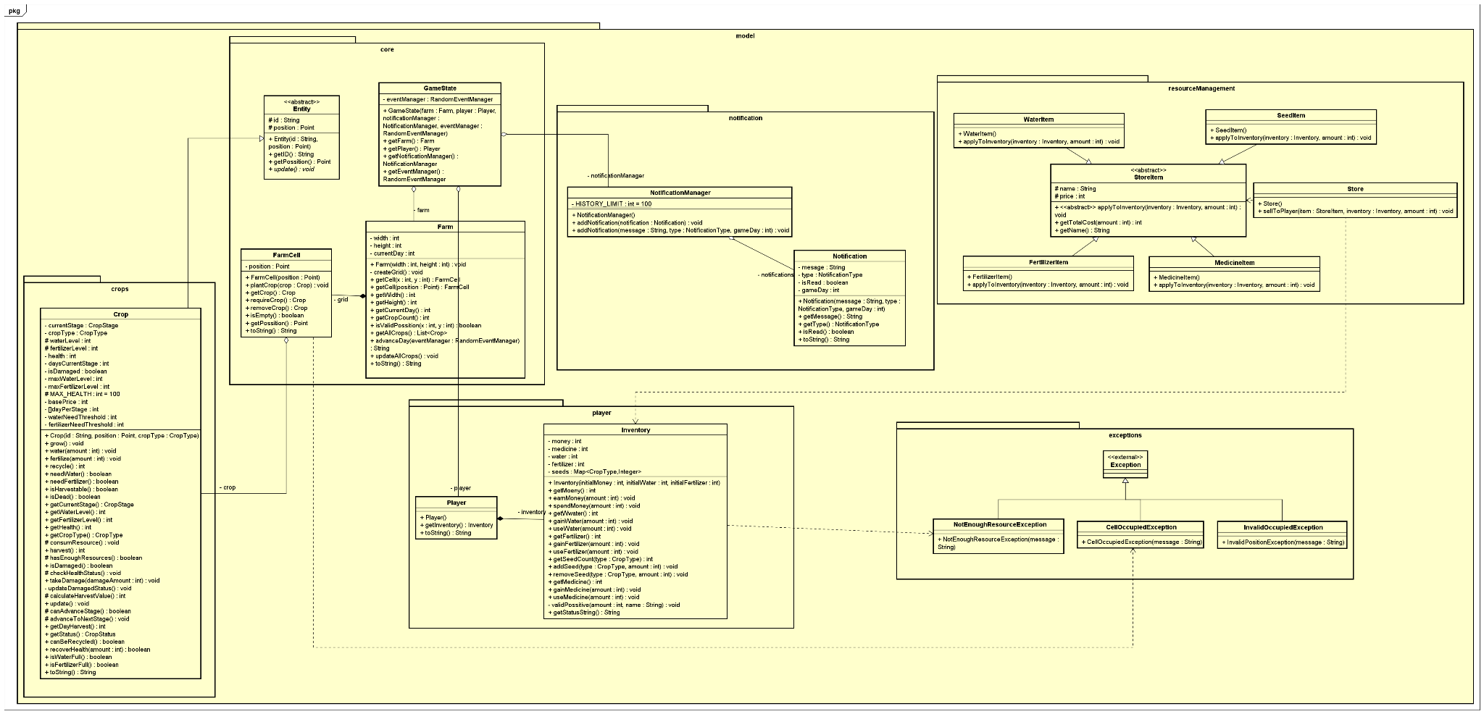

Figure 5.1 Model package

The Model layer contains the core business entities and game state. These classes are responsible for storing data and enforcing game rules, independent of user interface concerns.

#### **5.1.1 model.core**

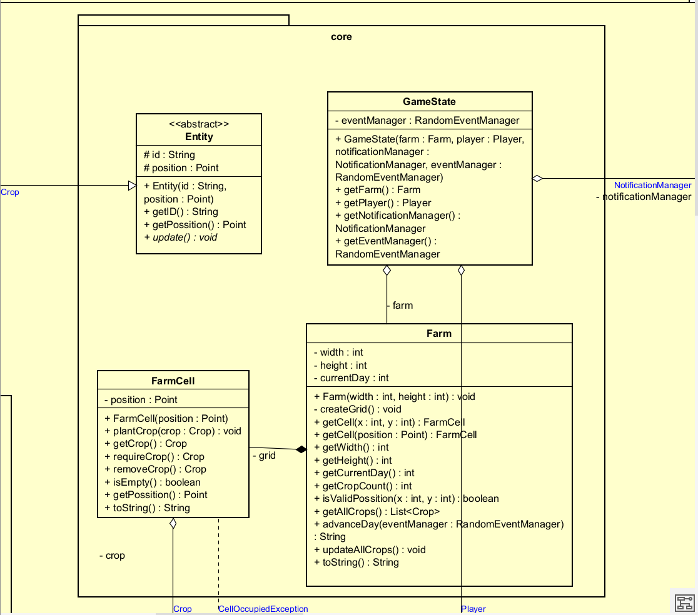

The sub-package manages the spatial coordinate system and the lifecycle of the farm grid.

* Entity (Abstract): The base class for all coordinate-involving objects, encapsulating an id and a Point position to standardize object location on the grid.
* Farm: implement a Composition relationship with FarmCell. It manages a 5x5 grid dimension (width, height) and tracks the currentDay. Key methods include createGrid(), which initializes the 2D array of cells, and advanceDay(), which coordinates daily updates across the grid.
* FarmCell: Acts as an Aggregation container for Crop objects. It includes defensive methods such as plantCrop(), removeCrop(), and isEmpty() to manage the state of individual plots.
* GameState: A wrapper class used for Serialization. It wraps the Farm, Player, NotificationManager, and RandomEventManager into a single object graph to be written to a targeted saved file.

#### **5.1.2 model.crops**

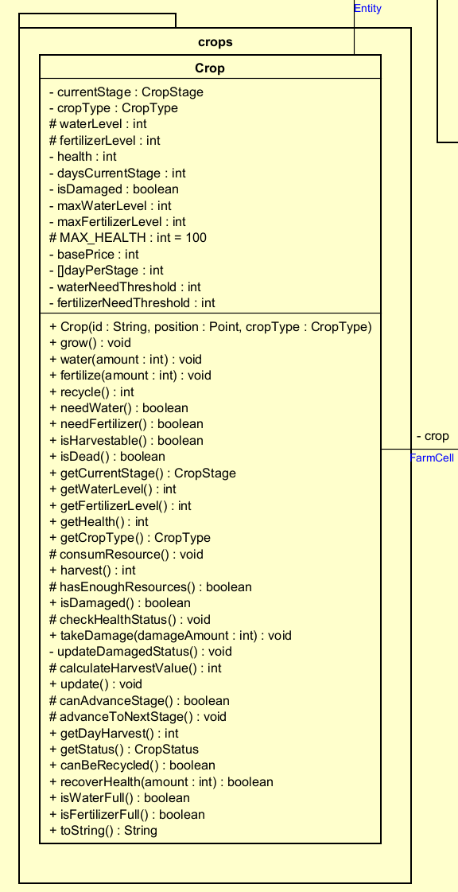

This package defines the behavior of the crops within the game with the Crop class - the central entity representing a plant and taking charge of maintaining and updating the plant's internal state. It tracks attributes such as health, waterLevel, fertilizerLevel, and currentStage.

There are some core methods including:

* grow(): Advances the crop’s lifecycle state based on predefined update cycle.
* consumeResource(): Reduces water and fertilizer levels as part of the daily update cycle.
* checkHealthStatus() and takeDamage(): Manage the crop’s condition
* harvest(): Returns the value of the crop.

#### **5.1.3 model.resourceManagement**

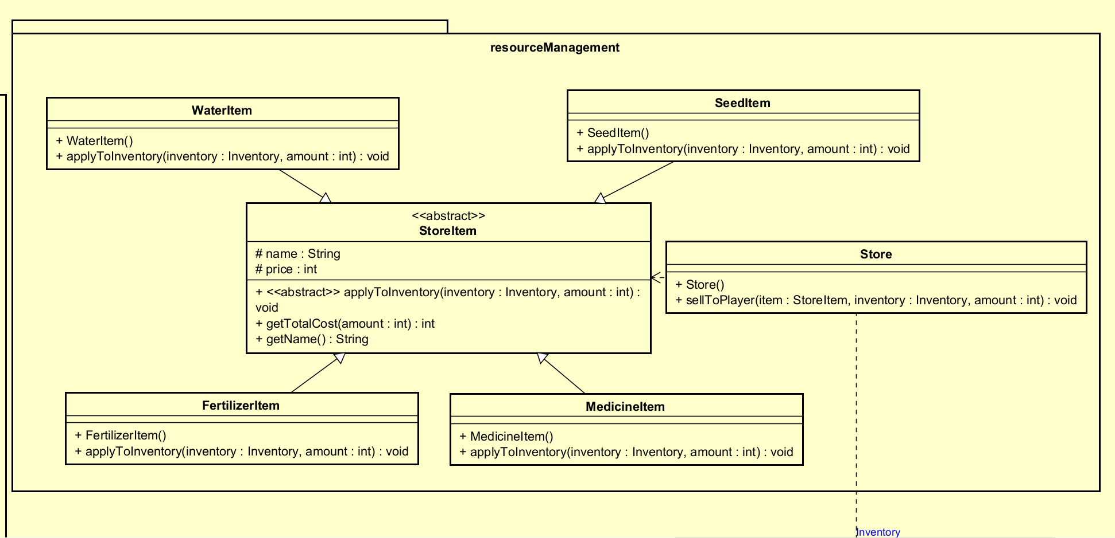

This package handles the logic for commerce and shop items:

* StoreItem (Abstract): The parent class for all purchasable items, defining attributes of name and price. It declares the abstract method applyToInventory(Inventory inventory), which allows child classes to specify how the purchased item affects player resources.
* Concrete Items: SeedItem, FertilizerItem, WaterItem, and MedicineItem extend from StoreItem. They implement the polymorphic method applyToInventory() to update the player’s stock upon purchase.
* Store: Facilitates transactions via the sellToPlayer() method, which coordinates the deduction of money and the addition of items. It does not own player resources but functions as a transaction coordinator between the store item and the player inventory.

#### **5.1.4 model.player**

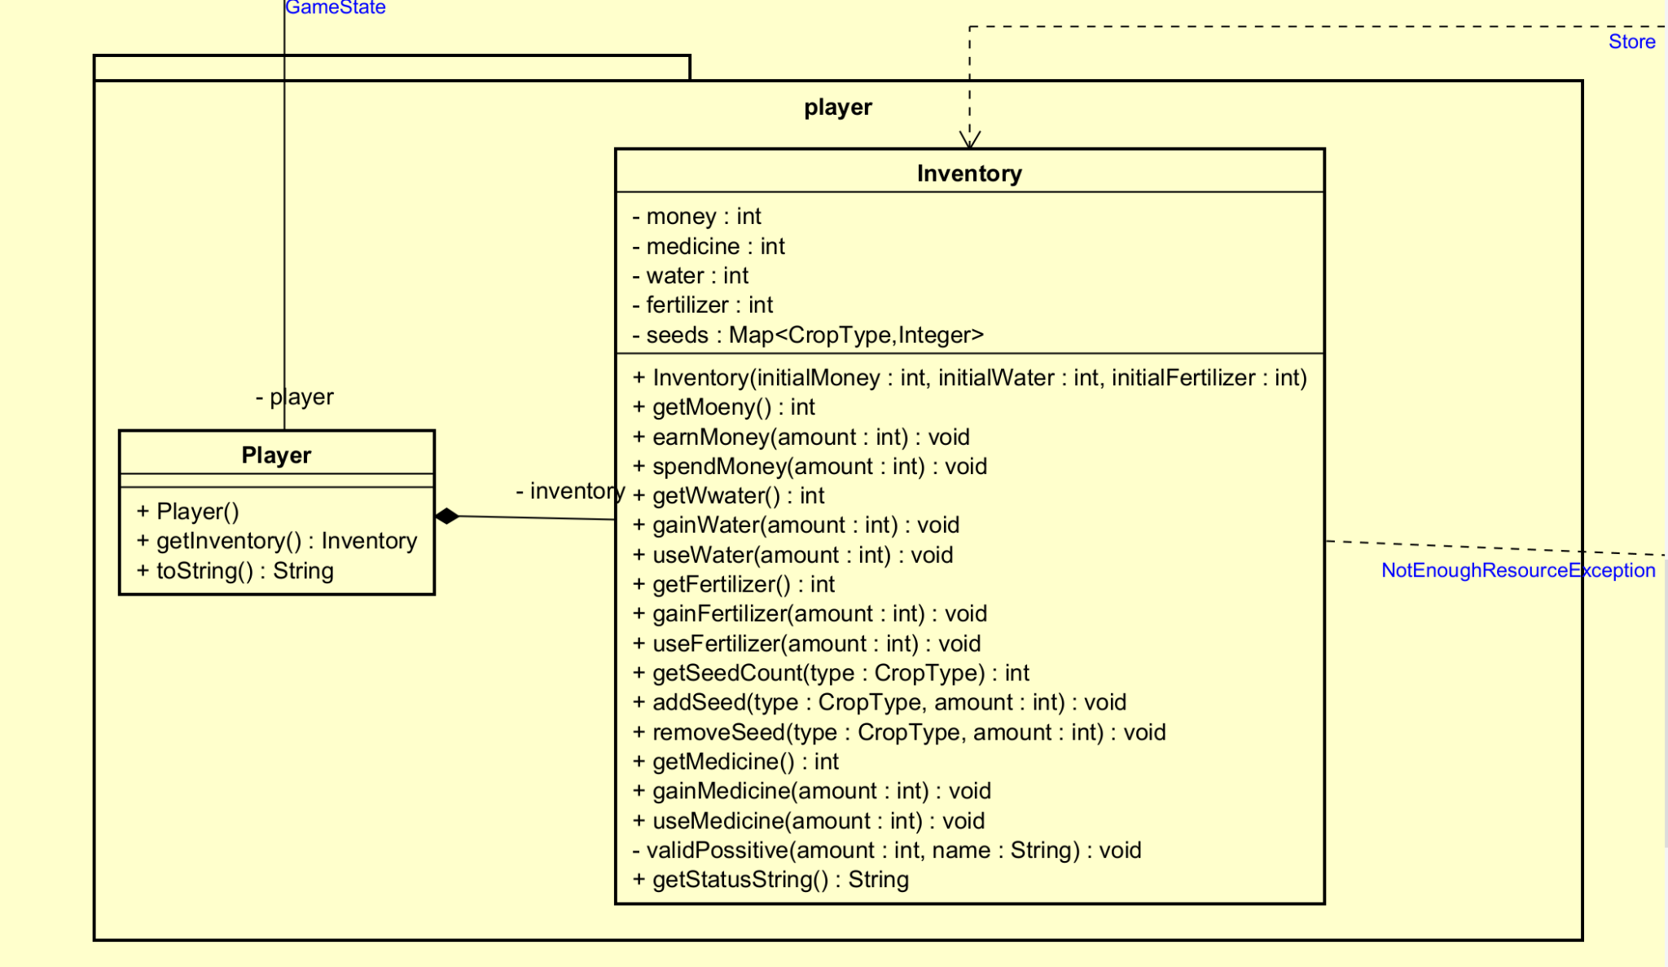

This package manages player-specific data and resources used during gameplay.

* Player: Represents the user entity and maintains player-related state. It owns an Inventory instance, which stores all player resources.
* Inventory: Tracks the quantities of player resources including money, medicine, water, fertilizer and seeds. It includes methods such as spendMoney(), gainWater(), and useFertilizer(), which throw exceptions if resources are insufficient.

#### **5.1.5 model.notification**

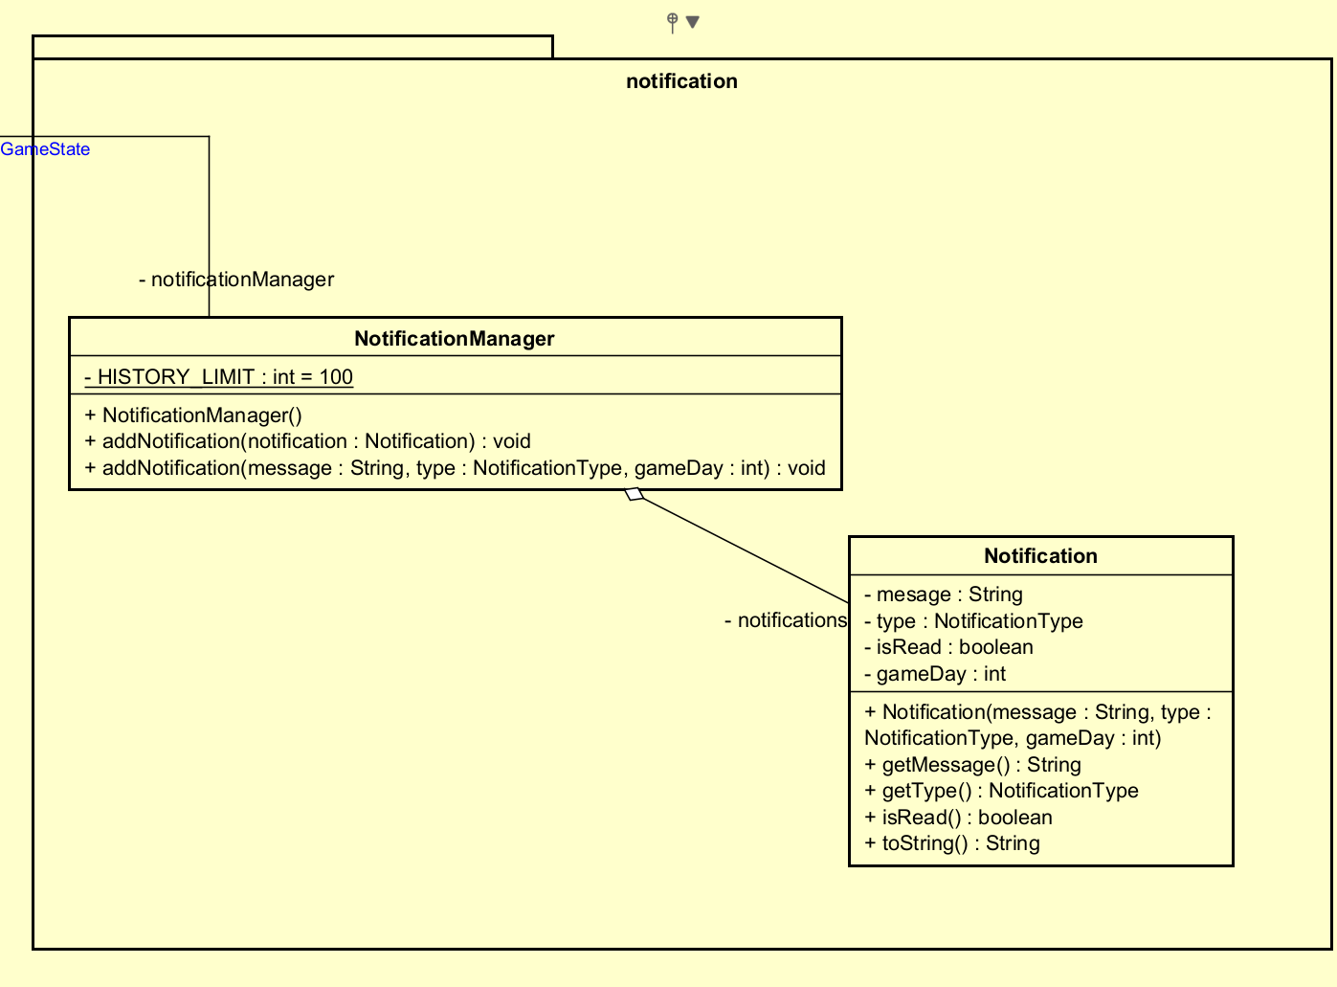

This package plays as an internal notification system for managing in-game alerts and system messages.

* NotificationManager: Maintains a list of notifications with a history limit (100 entries).It allows other components to log actions via addNotification() method.
* Notification: Represents a single message event with a message string, NotificationType and gameDay timestamp.

#### **5.1.6 model.exceptions**

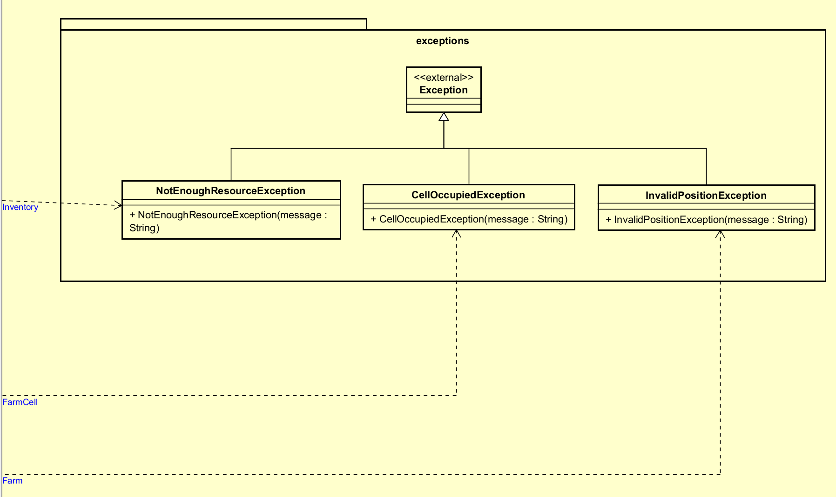

Custom exceptions are used to enforce business logic and ensure system integrity by preventing invalid operations from executing in the core game state.

* NotEnoughResourceException: Thrown when a player attempts to spend more money or resources than they currently have. This exception prevents illegal state transitions caused by resource management.
* CellOccupiedException: Thrown when attempting to plant on a non-empty cell. This ensures spatial consistency within the farm grid.
* InvalidPositionException: Thrown when accessing grid coordinates outside the farm bounds. This protects the system from invalid spatial access.

## 5.2 Controller Classes

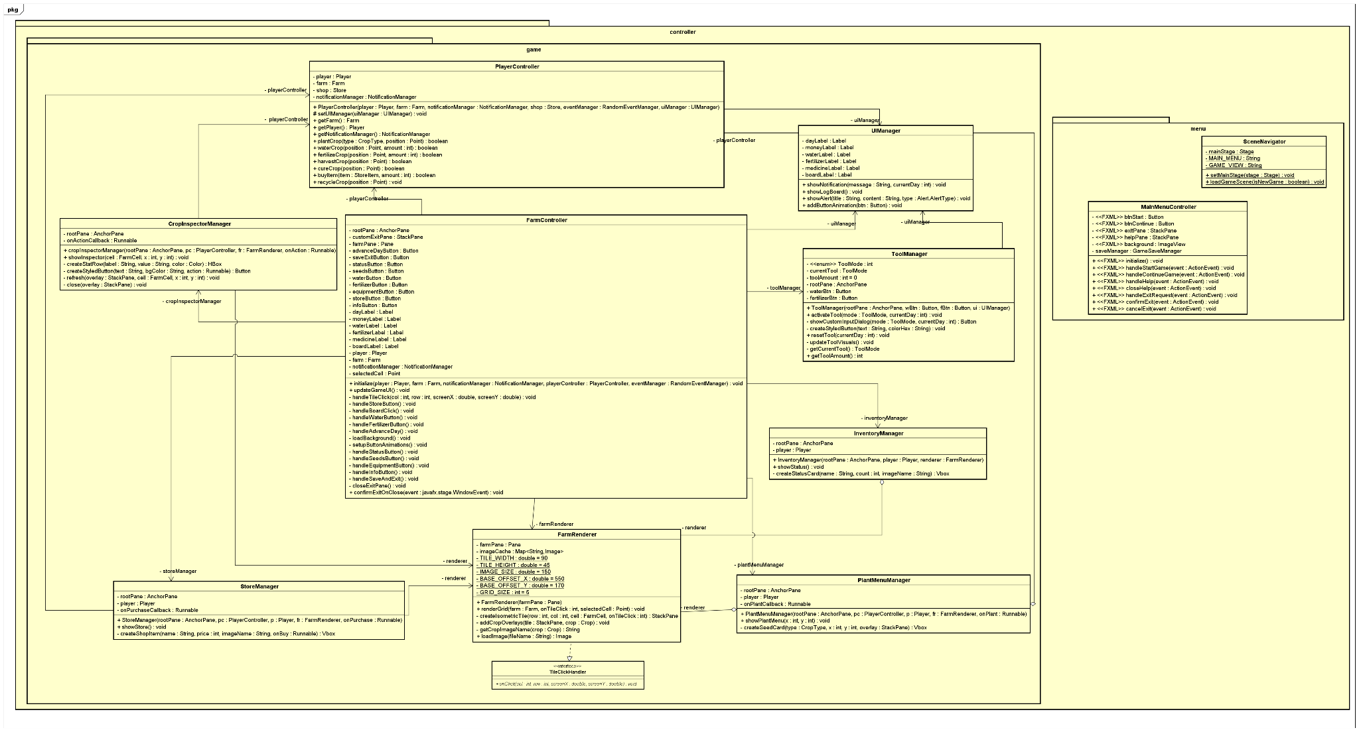

Figure 5.2 Controller package

The controller package mediates between the View and the Model:

* FarmController: This is the primary coordinator for gameplay logic. It handles interactions between the farm grid, player actions and the rendering system.
* PlayerController: Manages player-specific logic, such as buying items or using tools.
* ToolManager: Manages the state of currently selected tools ( Water Can, Fertilizer, Store, Inventory) and executes the corresponding action on the farm grid.
* StoreManager and InventoryManager: Controls the logic for their respective UI dialogs.
* FarmRenderer: Acting as a visual controller, this class is responsible for isometric projection logic. It translates logical grid coordinates into screen coordinates and maps mouse clicks on specific tiles back to game actions.
* CropInspectorManager: This manages the interaction logic when a player clicks on a crop. It determines which actions are valid and dynamically generates the inspection popup.
* PlantMenuManager: Controls the seed selection interface. It integrates with the Player model to validate seed inventory levels and renders the selection grid when a player clicks on an empty land tile.
* MainMenuController: This class handles the logic for the application’s entry point, managing button actions for “Start Game”, “Continue”, “Help” and “Exit”
* SceneNavigator: A utility controller responsible for the application’s flow. It manages the loading of FXML files and handles the transitions between the Main Menu and the Game View.

## 5.3 Service Classes

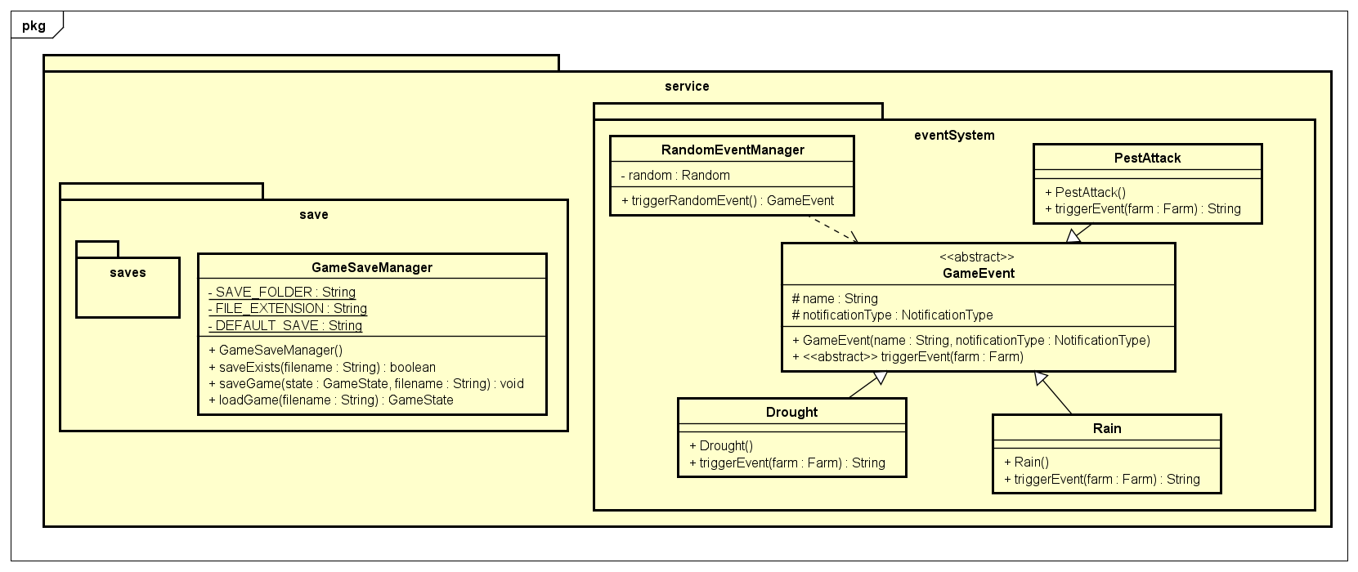

Figure 5.3 Service package

This package is designed to provide service-level components that support game features operating outside the core domain entities.

* RandomEventManager: Utilizes java.util.Random to determine daily weather events. Its responsibility is restricted to event selection and triggering, whilst the concrete effects of each event are delegated to the GameEvent child’s classes.
* GameEvent (Abstract): This is an abstract class that defines a common interface for all game events. Subclasses Rain, Drought, and PestAttack implement the triggerEvent(Farm farm) method to apply specific effects when the event happens.The Farm instance is passed as a parameter, allowing events to modify farm state without owning or managing its lifecycle. This polymorphism design enables flexible event handling while maintaining loose coupling between events and core entities.
* GameSaveManager: Handles data persistence using Java Serialization. It provides saveGame() and loadGame() operations implemented via ObjectOutputStream and ObjectInputStream to write the GameState to binary .dat files.

## 5.4 Utility Classes

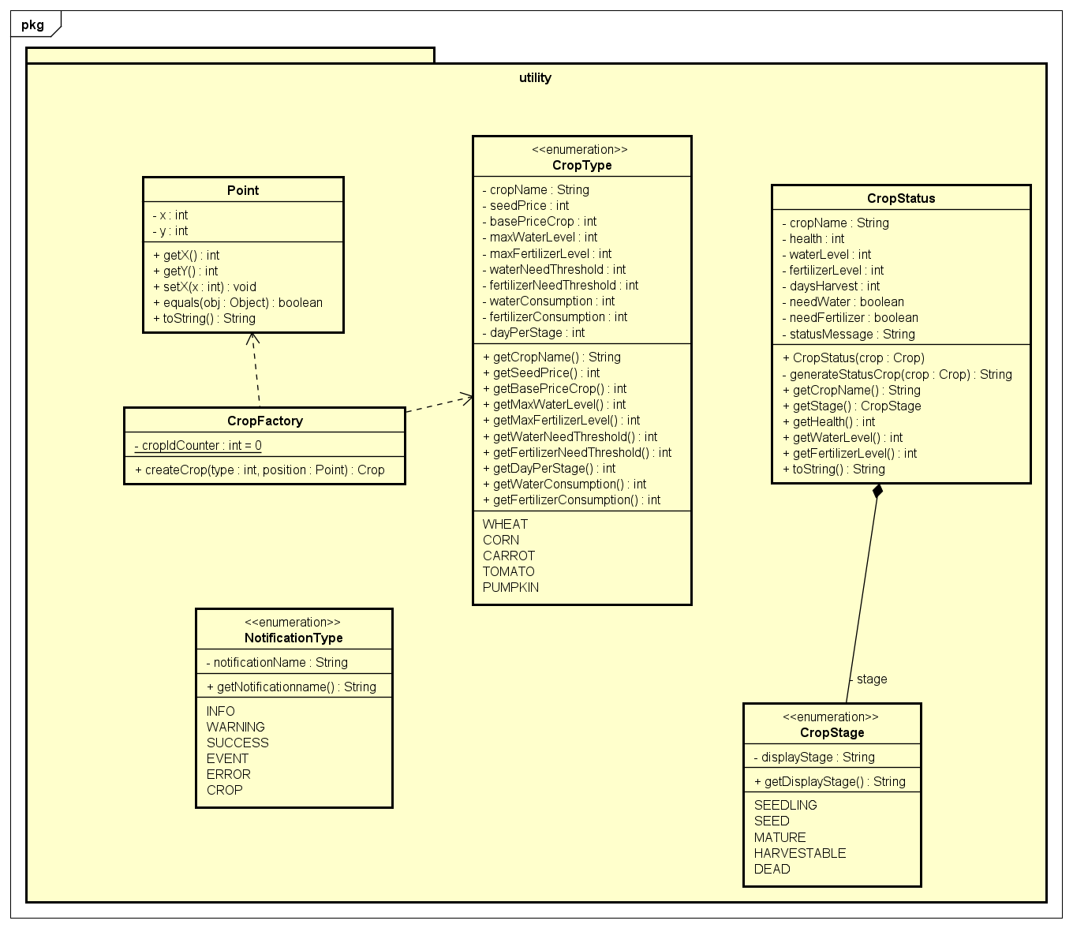

Figure 5.4 Utility package

This package contains shared components, enumeration and design patterns that are used across the application

* Point : A coordinate class (x,y) used for grid positioning. It provides a unified representation of spatial coordinates for all position-related entities in the system.
* CropFactory: Implements the Factory pattern to centralize and encapsulate crop creation logic. By delegating crop initialization to this class, the system avoids direct dependencies on specific crop construction and improves extensibility.
* CropType: Defines a fixed set of supported crop configurations and their associated parameters.
* CropStatus: Provides a representation of a crop’s current state for display and reporting purposes.
* CropStage: Defines the discrete lifecycle stages of a crop. This enumeration helps to standardize crop lifecycle states across the system and prevents any invalid stage transitions.
* NotificationType: Defines the category of system notifications. It ensures consistent classification and presentation of messages across different application modules.

# **CHAPTER 6: KEY GAME MECHANICS**

## 6.1 Crop Growth System

The crop growth system is the central mechanic of the game, governed principally by the Crop class and the CropStage enum.

* Growth Stages: Every crop progresses through a finite state machine defined in CropStage:
  + **SEED:** The initial state after planting.
  + **SEEDLING:** The germination phase.
  + **MATURE:** The crop is fully grown but may not be ready for optimal harvest.
  + **HARVESTABLE:** The final productive stage where the crop can be sold.
  + **DEAD:** A terminal state reached if health drops to zero.
* Growth Logic: The grow() method in the Crop class is called daily. It performs the following checks:
  + **Resource Consumption:** The crop consumes specific amounts of water and fertilizer defined by its CropType.
  + **Health Check:** The system verifies if the current water and fertilizer levels meet the waterNeedThreshold and fertilizerNeedThreshold. If resources are insufficient or depleted, the crop calls takeDamage().

public void grow(){

if(isDead()){

return;

}

consumeResource();

checkHealthStatus();

if(!isDead()&& hasEnoughResources()){

daysCurrentStage++;

if (canAdvanceStage()) {

advanceToNextStage();

}

}

}

* Stage Advancement**:** If the crop is healthy and alive, the daysCurrentStage counter increments. Once this counter meets the required duration for the specific stage (defined in dayPerStage), the method advanceToNextStage() transitions the crop to the next phase.

protected void advanceToNextStage() {

switch (currentStage) {

case ***SEED***:

currentStage = *CropStage*.***SEEDLING***;

break;

case ***SEEDLING***:

currentStage = *CropStage*.***MATURE***;

break;

case ***MATURE***:

currentStage = *CropStage*.***HARVESTABLE***;

break;

}

daysCurrentStage = 0;

}

## 6.2 Resource Management

Resource management forces the player to make strategic decisions regarding the allocation of limited assets. This is handled by the Inventory class and the model.resourceManagement package.

* **Core Resources:** The system tracks Money, Water, Fertilizer, Medicine, and Seeds.
* **Validation:** The Inventory class implements strict validation logic. To ensure data integrity, methods like spendMoney(), useWater(), and removeSeed() throw a NotEnoughResourceException if the player attempts to use more resources than available. Take useWater() for example:

public void useWater(int amount) throws NotEnoughResourceException{

validatePositive(amount, "Water");

if (this.water < amount) {

throw new NotEnoughResourceException("Not enough water.");

}

this.water -= amount;

}

* Replenishment:
  + **Water/Fertilizer:** Can be purchased from the store.
  + **Recycling:** The player can recycle dead crops via the recycle() method in Crop.java, which returns a small amount of fertilizer (5 units) as a consolation mechanic.
  + **Medicine:** Used via recoverHealth() to restore crop HP and remove the "Damaged" status.

## 6.3 Store and Economy System

The economy is driven by the cycle of buying seeds/tools and selling harvested products.

* **Purchasing:** The Store class facilitates transactions. The sellToPlayer() method calculates the total cost of items and delegates payment processing to the player's Inventory.

public void sellToPlayer(StoreItem item, Inventory inventory, int amount) throws NotEnoughResourceException{

int cost = item.getTotalCost(amount);

inventory.spendMoney(cost);

item.applyToInventory(inventory, amount);

}

* **Dynamic Harvest Value:** The selling price of a crop is not fixed. The calculateHarvestValue() method in Crop.java determines the profit based on the crop's health at the time of harvest:
  + **Standard Quality:** If health is between 1% and 50%, the crop sells for its base price.
  + **Premium Quality:** If health is above 50%, a bonus is applied. The formula is:

$$Value = Base Price + (\frac{Health}{100.0}* Base Price)$$

This incentivizes players to maintain high crop health rather than just keeping crops barely alive.

protected int calculateHarvestValue(){

if(!isHarvestable()){

return 0;

}

double value = basePrice;

if (health<=50 && health>0){

return (int) Math.*round*(value);

}

return (int) Math.*round*(value+(health/100.0)*value);

}

## 6.4 Random Event System

To introduce unpredictability, the game features a Random Event System implemented using the Strategy Pattern (or polymorphic hierarchy) in the service.eventSystem package.

* **Event Triggering:** The RandomEventManager determines if an event occurs at the start of a new day based on a probability roll (0-100):
  + **Rain (30% chance):** Implemented in Rain.java. Automatically adds water to all living crops.
  + **Drought (10% chance):** Implemented in Drought.java. Inflicts damage on all crops due to heat stress.
  + **Pest Attack (5% chance):** Implemented in PestAttack.java. Iterates through crops and has a 30% chance to inflict heavy damage (30 HP) on individual crops.
  + **None (55% chance):** A normal day with no special effects.

public GameEvent triggerRandomEvent() {

int roll = random.nextInt(100);

if (roll < 30) {

return new Rain();

} else if (roll < 40) {

return new Drought();

} else if (roll < 45) {

return new PestAttack();

} else {

return null;

}

}

## 6.5 Save/Load Functionality

The persistence layer allows players to retain their progress between sessions, managed by the GameSaveManager.

* **Serialization:** The system utilizes Java’s Serializable interface. The GameState class acts as a wrapper, encapsulating the Farm grid, Player inventory, and NotificationManager.
* **Binary Storage:**
  + The saveGame() method writes the GameState object state directly to a .dat file (defaulting to smartfarm_save.dat) using ObjectOutputStream.

public void saveGame(GameState state, String filename) throws IOException {

String fullPath = ***SAVE_FOLDER*** + filename + ***FILE_EXTENSION***;

try (ObjectOutputStream oos = new ObjectOutputStream(new

FileOutputStream(fullPath))) {

oos.writeObject(state);

}

}

* + Conversely, loadGame() reconstructs the object graph from the binary file, restoring the exact state of the grid and inventory.

public GameState loadGame(String filename) throws IOException, ClassNotFoundException {

String fullPath = ***SAVE_FOLDER*** + filename + ***FILE_EXTENSION***;

File file = new File(fullPath);

if (!file.exists()) {

throw new FileNotFoundException("No saved file found.");

}

try (ObjectInputStream ois = new ObjectInputStream(new

FileInputStream(fullPath))) {

return (GameState) ois.readObject();

}

}

## 6.6 Day Progression

The flow of time is manual, triggered by the player, ensuring they have time to perform actions before the day ends. The Farm class orchestrates the passage of time. The advanceDay method acts as a coordinator, triggering events and updating every entity on the grid.

* The Advance Day Cycle:
  + **Event Trigger:** RandomEventManager is queried to see if a weather event occurs.
  + **Crop Updates:** The Farm iterates through every FarmCell. If a crop exists, its grow() method is executed. This updates water/fertilizer levels, calculates damage from shortages, and advances growth stages.
  + **UI Updates:** The FarmController refreshes the view to reflect new crop sprites (e.g., growing from Seedling to Mature) and updates the day counter.
  + **Notifications:** The player receives a summary of the day's events (e.g., "Drought appears, all crops suffer damage").

public String advanceDay(RandomEventManager eventManager) {

System.***out***.println("Day " + currentDay + " ended.");

currentDay++;

System.***out***.println("\nDay " + currentDay + " begins...");

GameEvent event = eventManager.triggerRandomEvent();

String eventResult = null;

if(event!= null){

eventResult=event.triggerEvent(this);

}

updateAllCrops();

return eventResult;

}

# 

# 

# 

# 

# **CHAPTER 7: OOP PRINCIPLES APPLIED**

## 7.1 Inheritance

Inheritance is used to create a hierarchical structure, allowing child classes to reuse attributes and behaviors from the parent class.

* Entity Hierarchy: The abstract class Entity class provides the foundation for all physical objects on the farm by defining shared properties (id, position). The Crop class inherits these properties, ensuring that every plant has a unique identity and a specific coordinate on the grid.
* Store Item Hierarchy: To manage diverse products, the system uses an inheritance tree where StoreItem plays as the parent. Child classes including WaterItem, SeedItem, FertilizerItem and MedicineItem inherit the price and name attributes.
* Event Hierarchy: Environmental unexpected events are organized under the GameEvent parent class. Specific events (Rain, Drought, Pest Attacks) inherit the basic structure of a game event while preserving their own unique logic mechanism.

While inheritance is a powerful OOP principle, we intentionally prioritize composition to model crop types in order to avoid class explosion since creating a subclass for each crop would result in rigid hierarchy and poor scalability. Instead, the Crop class has a CropType enum. The Crop class can manage dynamic state, while CropType defines static properties of the specific crops.

## 7.2 Encapsulation

Encapsulation is applied to protect the internal state of objects and ensure that data can only be modified through controlled interfaces.

* Data Hiding:

Private fields: Classes such as Inventory, Farm, FarmCell and NotificationManager declare their primary data fields as private.

Protected fields: In the Entity and StoreItem hierarchies, certain fields such as id, position, name, and price are marked protected. This allows child classes to access necessary data while still keeping it hidden from unrelated external controllers.

* Controlled Access via Methods: Modification of the internal state is restricted to public methods that enforce game rules. For instance, the spendMoney(amount: int) method checks if the player has sufficient money before performing the subtraction, making sure that the system will not encounter an invalid negative state.

## 7.3 Polymorphism

Dynamic polymorphism is utilized effectively in this project, which allows the application to decide which specific behavior to execute at runtime rather than compile-time.

* Store Item and Purchase Logic: StoreItem provides the abstract method applyToInventory(Inventory inventory, int amount). Child classes including SeedItem, WaterItem, FertilizerItem and MedicineItem each override this method to update the correct resource count in the player’s inventory.

The PlayerController.buyItem method accepts a generic StoreItem reference. When shop.sellToPlayer is called, it triggers the specific applyToInventory behaviour of the item being purchased.

* Environmental Event Management: The system handles various daily occurrences through a hierarchy rooted in the abstract GameEvent class. This structure allows the game to treat different impacts as a single unified type during execution.

In the Farm.advanceDay method, the system receives a GameEvent reference from the RandomEventManager and calls event.triggerEvent(this). At runtime, the compiler executes the logic of the subclass without the Farm class needing to know the specific event type.

* Entity Update System: The abstract Entity class defines an abstract update() method. The child class Crop inherits from Entity and overrides the update() method. When Crop.update() is called, it triggers the internal grow() logic and then each entity performs its own specific lifecycle logic.

## 7.4 Abstraction

Abstraction is used to hide complex implementation details and show only the necessary features of an object, allowing the game to interact with generalized behavioral contracts rather than specific subclasses.

Abstract classes define mandatory behaviors via abstract methods ensuring consistency while enabling flexibility.

* Entity: Provides a common abstraction for all in-game objects, allowing systems to manage entities uniformly without knowledge of their concrete types.
* StoreItem: Defines a purchasing contract that hides item-specific inventory logic from store and controller components.
* GameEvent: Abstracts environmental effects, enabling the system to trigger events without distinguishing between specific event types.

# **CHAPTER 8: LIMITATIONS AND FUTURE WORK**

## 8.1 Current Limitations

Despite meeting the core objectives, the current version of "Smart Farm" has several limitations:

* Scale and Variety: The farm is restricted to a fixed 5x5 isometric grid, which may limit long-term gameplay engagement for advanced users.
* Single-Player Constraint: The system is designed strictly for a desktop single-player experience, lacking social or competitive features.
* Static Progression: Time progression is entirely manual, requiring the player to click "Next Day," which lacks the dynamic feel of real-time simulation games.
* Basic Economic Model: The store system utilizes fixed pricing for resources and a relatively simple formula for harvest values, without market fluctuations or complex trade mechanics.
* Limited Asset Library: The game features only five types of crops and three main environmental events, which may lead to repetitive gameplay over extended sessions.

## 8.2 Proposed Improvements

Future iterations of the project could incorporate the following enhancements:

* Expanded Environment: Implementing expandable farm plots or different terrain types (e.g., greenhouses or orchards) with unique growth conditions.
* Advanced Game AI: Introducing NPC (Non-Player Character) assistants or automated farming tools to assist with resource management.
* Enhanced Visuals: Adding animations for crop growth stages, weather effects like moving clouds/rain, and specialized sound effects to improve immersion.
* Multiplayer Functionality: Developing a networking layer to allow players to visit each other's farms or trade resources in a shared marketplace.
* Mobile Cross-Platform Support: Transitioning the JavaFX interface to a mobile-friendly framework to allow users to manage their farms on the go.

# 

# **CHAPTER 9: CONCLUSION**

## 9.1 Project Summary

The "Smart Farm" project successfully achieved its goal of developing a functional farming simulation game using Java and the JavaFX framework. By implementing a robust Model-View-Controller (MVC) architecture, the system maintains a clear separation between game logic, user interface, and service-level operations. Key features such as the multi-stage crop growth system, resource management, and random environmental events demonstrate a cohesive integration of complex programming logic into an engaging user experience.

## 9.2 Learning Outcomes

This project served as a vital practical application of theoretical Object-Oriented Programming (OOP) concepts. Through the development process, the following outcomes were achieved:

* **Practical OOP Mastery**: Gained hands-on experience in using inheritance to establish hierarchical structures for Entity, StoreItem, and GameEvent, while prioritizing Composition between Crop and CropType for increased extensibility; polymorphism for environmental events; and encapsulation for protecting game state data.
* **Architectural Design**: Learned to design and implement a layered MVC pattern, which is essential for building scalable and maintainable software.
* **GUI Development**: Developed proficiency in JavaFX, FXML, and Scene Builder to create intuitive, responsive, and visually themed user interfaces.
* **Problem Solving**: Successfully implemented advanced features like Java Serialization for game persistence and custom exception handling for resource validation.

## 9.3 Final Remarks

In conclusion, "Smart Farm" effectively bridges the gap between abstract computer science theory and practical software engineering. While there is room for expansion in terms of features and scale, the project stands as a solid foundation for simulation-based learning and demonstrates the power of Java in creating structured, interactive applications.

# 

# 

# 

# 

# 

# 

# 

# **REFERENCES**

1. [Design Choice: Composition Over Inheritance](https://viblo.asia/p/liskov-substitution-principle-voi-composition-over-inheritance-AZoJjXd2VY7)
2. [Exception handling in Java](https://viblo.asia/p/xu-ly-exception-dung-cach-trong-java-obA46OxGJKv)
3. [Isometric Tilemap Coordinate Transformation](https://stackoverflow.com/questions/39729815/converting-screen-coordinates-to-isometric-map-coordinates)
4. [**Eric Freeman & Elisabeth Robson (2020)**. Head First Design Patterns: Building Extensible and Maintainable Object-Oriented Software. O'Reilly Media.](https://github.com/ajitpal/BookBank/blob/master/%5BO%60Reilly.%20Head%20First%5D%20-%20Head%20First%20Design%20Patterns%20-%20%5BFreeman%5D.pdf)